Practical-5
Task-1
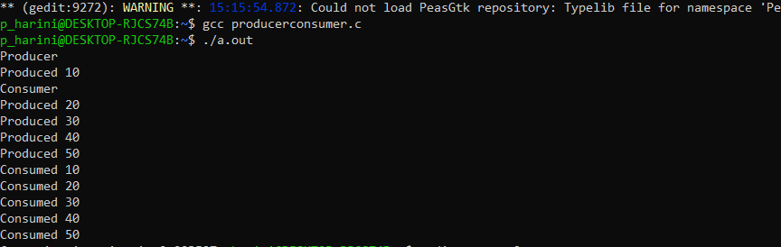

Task-2

